Solitaan’s TESA: Redguard Speedrun Route Outline
Legend:
Gold
Skip
Dialogue
Shrines of Kynareth
Item Use
Item Get
Boat Health: 97
+53g
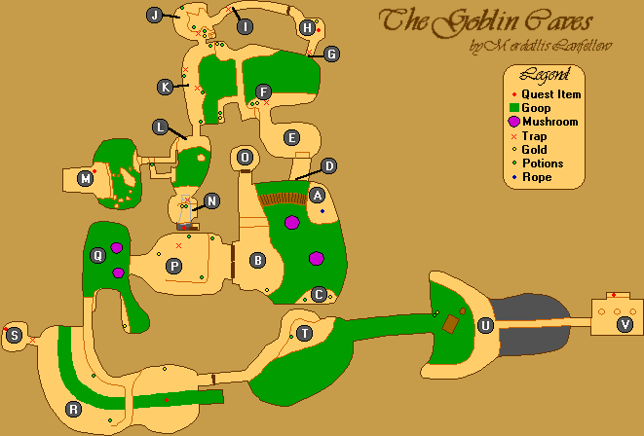
Teleporter Skip
Ogre +300g
(SPLIT) Cave Exit (65 Health)
Gerrick:
- Buy Items
  - Shovel -30g
  - Aloe -15g
  - Compass -50g
  - Feather x10 -100g
- Iszara
- League Pirates
- Knows More
- Smuggler’s Den
(↖) Town -> Devil’s Den
Boneman -3g
(SPLIT) N’Gasta’s Amulet

(←) Devil’s Den -> Ogre Mountains
Glass Bottle
(→) Ogre Mountains -> Town
Avik: (-1g)
- Music
- Yokudan Lad
Eyepiece
Palace Guard:
- See Richton
  - (SPLIT) Deliver Amulet
Prisoner:
- Escape
- Find League
- Lighthouse
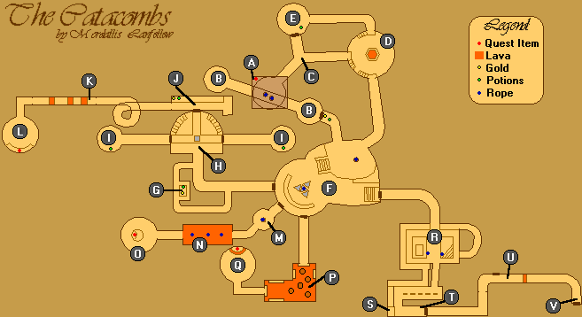
Strength and Torch
Rune Door Skip
(SPLIT) Escape

Prnell:
- Iszara
- Eyepiece
Krisandra:
- Smuggler’s Den
- Lakene
Locket
Lakene:
- Locket
J’ffer:
- Buy Books
  - Dwarven Lore (-54g)
Lakene:
- Gambling at Den
- Give Me Password
- Give Locket
Urik:
- Iszara
- Malachite
- League Insignia
  - You Were Iszara’s Friend
    - She Would Have Liked You
(SPLIT) League Insignia
Health
(↙) Town -> Ruins
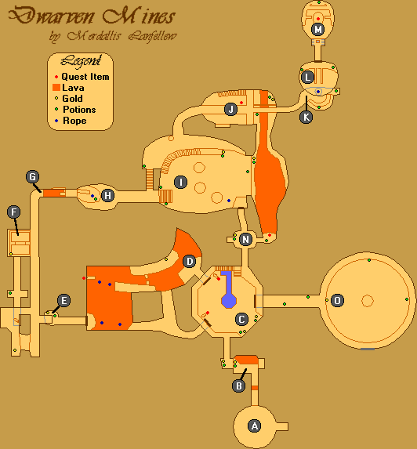
Scarab Door Skip
(→) Ruins -> Saintsport
Observatory
Lighthouse flashes: short, short, long
Fast lighthouse descent strat
(SPLIT) League Hideout
Strength
Basil:
- Iszara
- Iszara’s Messenger Boy
- Part of You
(↑) Saintsport -> Town

Nidal:
- Temple
- Brother Kithral
- Kithral’s Journal
Mariah
Falicia:
- Soulgem
Joto:
- Joto
- Magic
- Please
- Iszara
(SPLIT) Old Quarter
Health
(↓) Town -> Saintsport
(SPLIT) Flask of Lillandril
(↖) Saintsport -> Ogre Mountains
(↖) Ogre Mountains -> Devil’s Den
Boatman (-3g)
Orc’s Blood + Amber
Hist Sap + Unicorn’s Horn
Ectoplasm + Deadra Heart
Clavicus Vile:
- Daedra
- Why Are You Doing This?
  - Give Flask for Sister’s Soul
  - What Do You Want?
    - Wager My Soul Against Sister's Soul...
(SPLIT) Iszara’s Soul
(↑) Saintsport -> Town
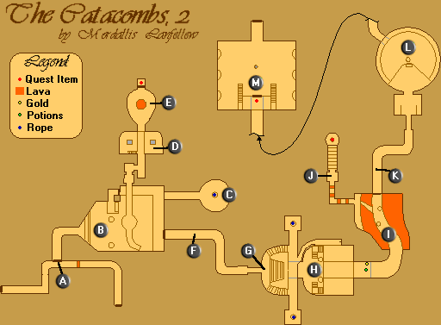
Weights puzzle:
-*******
--******
---*****
**-*****
**---***
**-*--**
**-**-**
*--**-**
Coyle:
- Hayle
- Is Your Mother All Right?
- Soul Snare
- Serpent
- Serpent’s Path
- Yes
Saban:
- Help with Soulgem
(SPLIT) Palace Courtyard
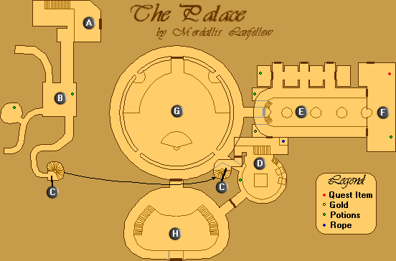
(SPLIT) Richton

